Verbal Predicate

✅ What Is a Verbal Predicate?
# Source: AI Source: Provided by: [Data Path: Persons Table -> ID Column: 1, Name_En Column: Motasem Essam] -> From: [ChatGPT] on [8/4/2025]
A Verbal Predicate is the most basic and common type of predicate. It consists of a main verb (or verb phrase) that expresses an action or a state directly related to the subject. It does not use a linking verb followed by a complement (like in nominal predicates).

🔸 Key Features:
# Source: AI Source: Provided by: [Data Path: Persons Table -> ID Column: 1, Name_En Column: Motasem Essam] -> From: [ChatGPT] on [8/4/2025]
- The predicate is built around a verb (hence “verbal”).
- It shows what the subject does, did, will do, or is doing.
- Can include:
  - Action verbs (run, eat, sleep)
  - Auxiliary verbs (is running, has eaten)
  - Modal verbs (can go, should study)

🔸 Examples:
# Source: AI Source: Provided by: [Data Path: Persons Table -> ID Column: 1, Name_En Column: Motasem Essam] -> From: [ChatGPT] on [8/4/2025]
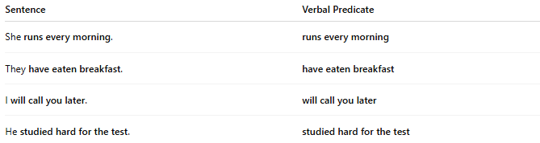
Sentence | Verbal Predicate
She runs every morning. | runs every morning
They have eaten breakfast. | have eaten breakfast
I will call you later. | will call you later
He studied hard for the test. | studied hard for the test

🔸 Compare With Nominal Predicate:
# Source: AI Source: Provided by: [Data Path: Persons Table -> ID Column: 1, Name_En Column: Motasem Essam] -> From: [ChatGPT] on [8/4/2025]
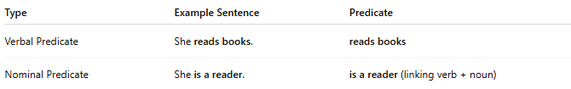
Type | Example Sentence | Predicate
Verbal Predicate | She reads books. | reads books
Nominal Predicate | She is a reader. | is a reader (linking verb + noun)

